**Introduction to Databases Exercise**

Ques1 Create Database

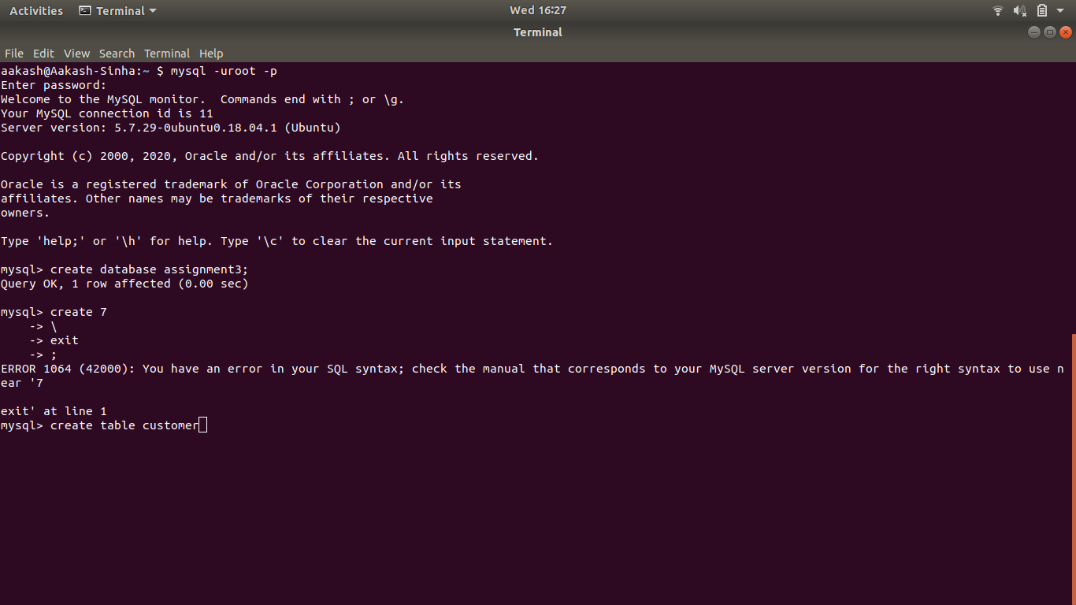

Ques 2 Design Schema

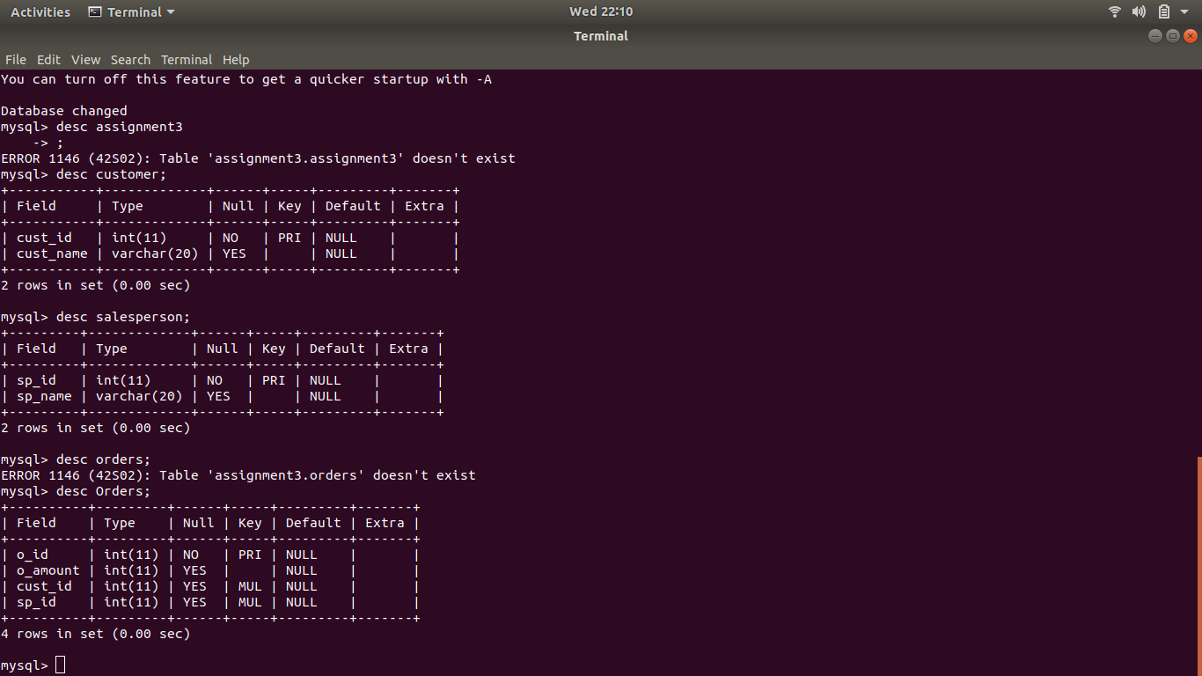

Ques 3 Create tables

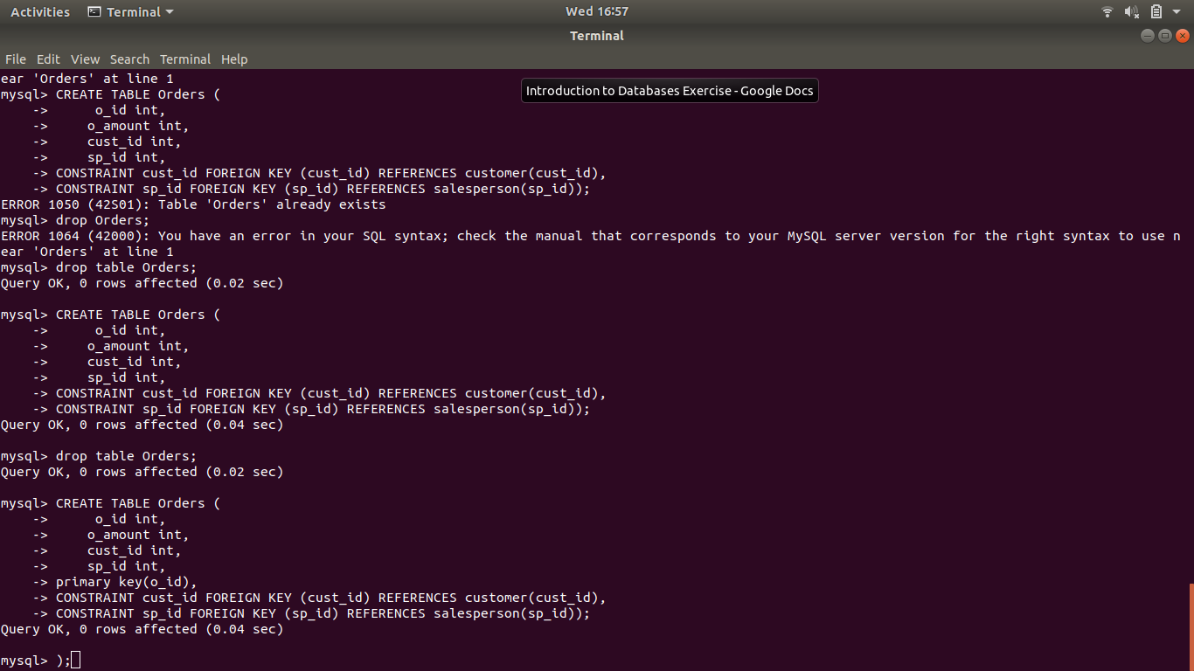

Ques 4 Insert sample data

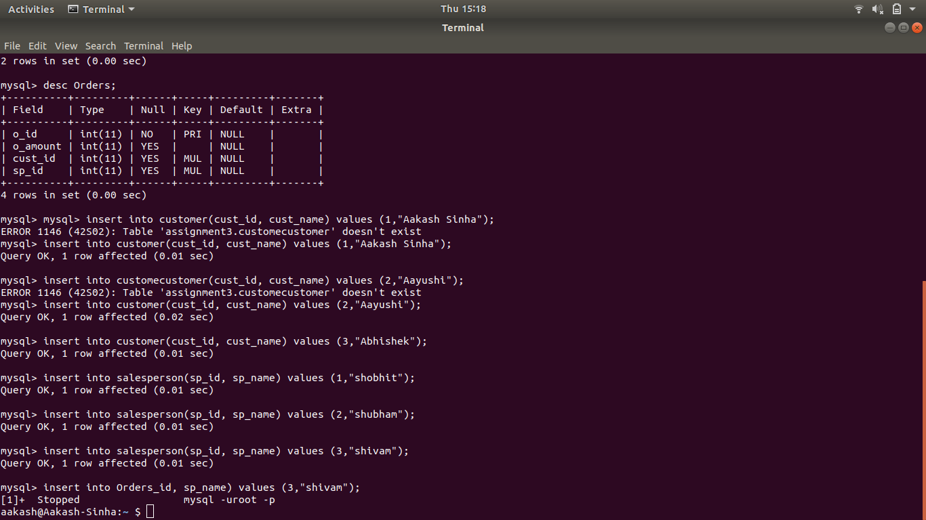

Ques 5 Find the sales person have multiple orders.

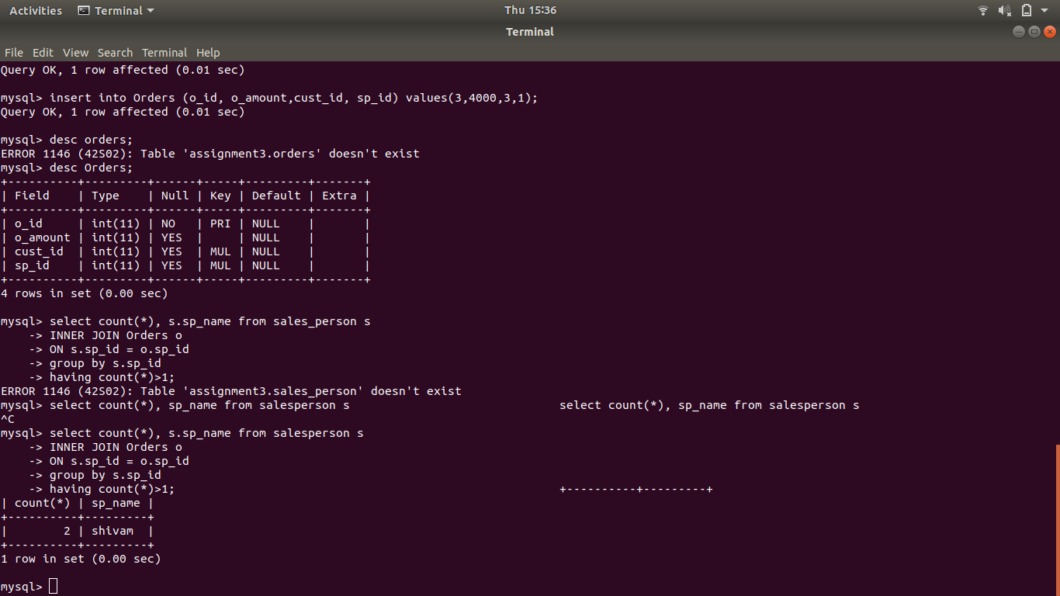

Ques 6 Find the all sales person details along with order details

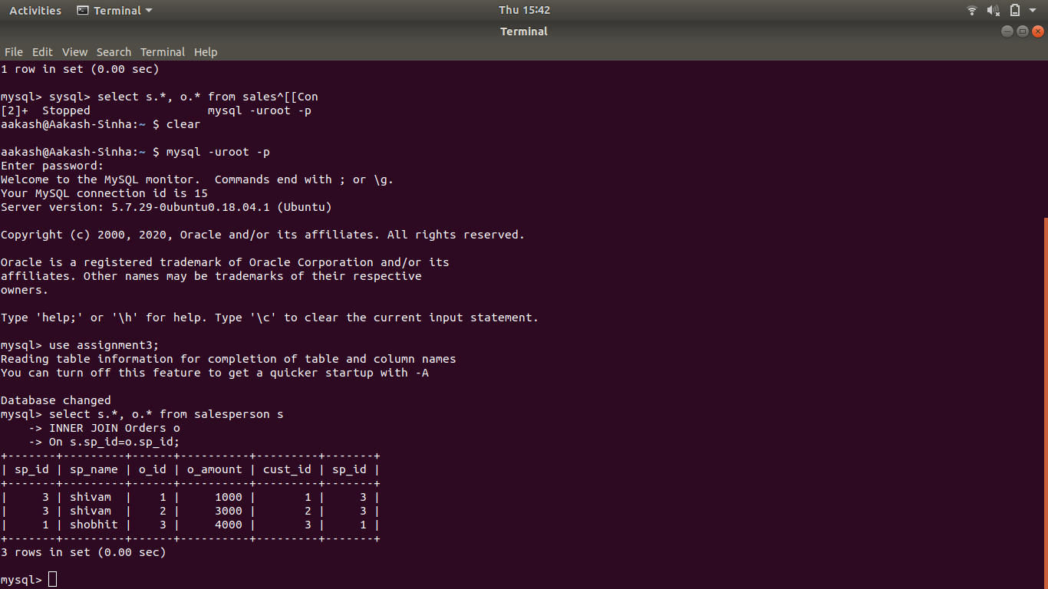

Ques 7 Create index

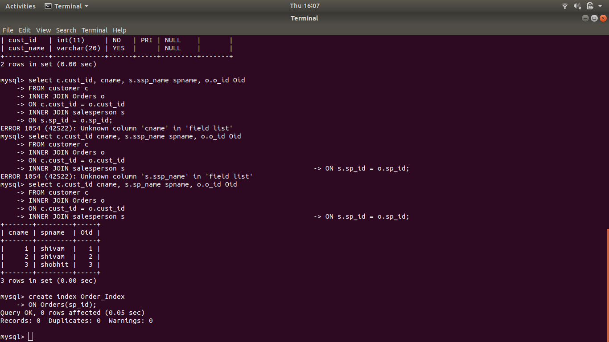

Ques 8 How to show index on a table

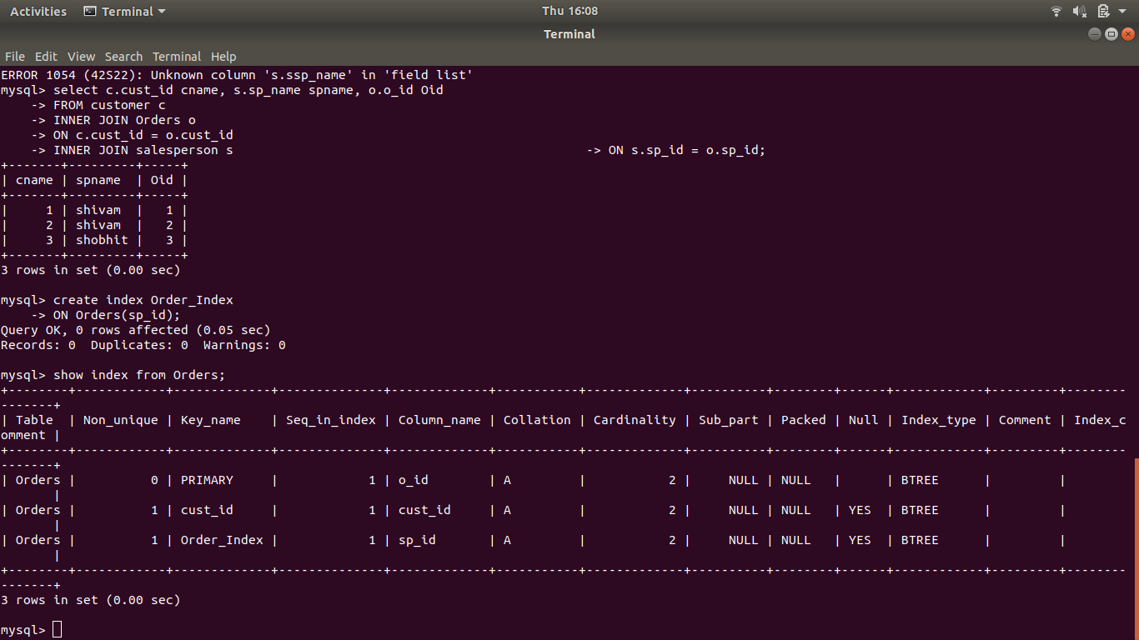

Ques 9 Find the order number, sale person name, along with the customer to whom that order belongs to

